TOEIC LISTENING TRANSCRIPT
Test 1 — Full Audio Script (Part 1, Part 2 & Part 3)

PART 1: PHOTOGRAPHS (Questions 1 – 6)
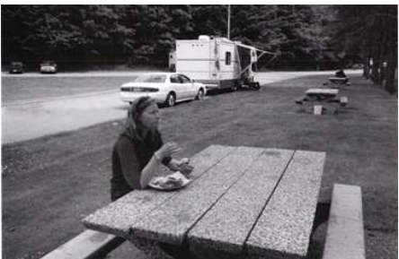
Number 1
(A) She’s eating in a picnic area.
(B) She’s waiting in line at a food truck.
(C) She’s wiping off a bench.
(D) She’s throwing away a plate.
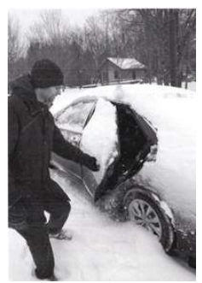
Number 2
(A) The man is brushing snow off the roof of a car.
(B) The man is standing in the snow beside a car.
(C) The man is shoveling snow from a walkway.
(D) The man is running through the snow.
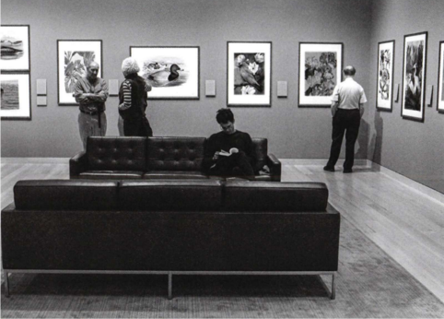
Number 3
(A) Some workers are hanging art in a gallery.
(B) Two of the people are having a conversation.
(C) One of the men is rearranging cushions on a sofa.
(D) One of the men is painting a picture.
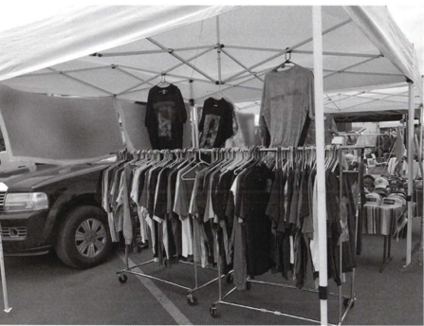
Number 4
(A) Vehicles are entering a parking garage.
(B) Clothes hangers are scattered on the ground.
(C) Empty racks are lined up next to a building.
(D) Clothing is being displayed under a tent.

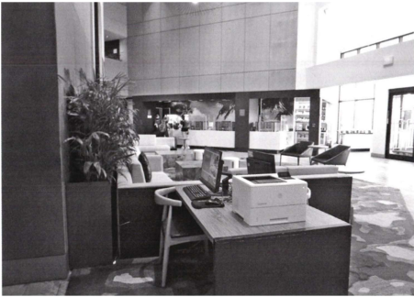
Number 5
(A) Potted plants have been suspended from a ceiling.
(B) Chairs have been stacked in front of an entryway.
(C) A computer station has been set up on a desk.
(D) A rug has been rolled up against a wall.
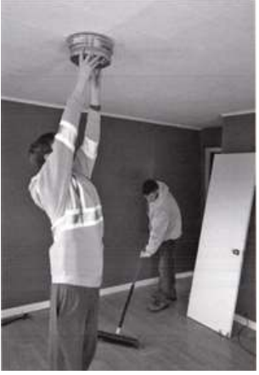
Number 6
(A) One of the men is sweeping a patio.
(B) One of the men is replacing some flooring.
(C) A door has been taken off its frame.
(D) A light fixture has been left on the ground.

PART 2: QUESTION-RESPONSE (Questions 7 – 31)
Number 7: How old is this building?
(A) To ship some materials.
(B) About 10 years old.
(C) Company offices, I think.
Number 8: Can you come to my jazz performance tonight?
(A) I’m sorry I was late for the meeting.
(B) Mostly just local musicians.
(C) Sure, I’ll be there.
Number 9: Which apartment submitted a work order?
(A) It’s what you did for a living.
(B) Submit your assignment here.
(C) It came from the tenants in B23.
Number 10: Will you contact the vendor about changing our delivery date?
(A) Of course, I’ll take care of it.
(B) An email receipt.
(C) Could I get change for a dollar?
Number 11: Why was the maintenance worker here?
(A) No, he didn’t.
(B) From 3 o’clock until 4.
(C) Because a light needed to be fixed.
Number 12: Did management make a hiring decision yet?
(A) Put it on the highest shelf.
(B) The personnel department.
(C) Yes, they chose Jacob Borgman.
Number 13: Do you want to eat here in our cafeteria or go out?
(A) He went there yesterday.
(B) Well, maybe a sandwich.
(C) Let’s eat here.
Number 14: Didn’t you email the employment contract to Mr. Patel yesterday?
(A) Yes, I would agree.
(B) No, I’ll send it now.
(C) Check the employee manual.
Number 15: Our division’s picnic is this Saturday, right?
(A) There’s a lot of rain in the forecast.
(B) Sure, I like salad.
(C) At the end of this corridor.
Number 16: Would you like coffee or tea?
(A) Just water, please.
(B) For a few dollars more.
(C) A 15-minute break.
Number 17: We achieved our sales targets this month.
(A) That’s excellent news.
(B) A few times a day.
(C) To the end of April.
Number 18: How often do you travel for your job?
(A) It turned out well.
(B) Yes, I did find one.
(C) About once a month.
Number 19: We should hike the Wildflower Trail today.
(A) This seat is available.
(B) I didn’t bring boots.
(C) At the visitors’ center.
Number 20: You’ve booked a hotel in London, haven’t you?
(A) Very enjoyable, thanks.
(B) He usually takes the train.
(C) Yes, I made a reservation last week.
Number 21: Are there any tickets left for tonight’s concert?
(A) It’s sold out.
(B) He’s a concert violinist.
(C) They already left.
Number 22: Haven’t you used this software before?
(A) Can I take your order?
(B) I haven’t had the chance.
(C) About $40.
Number 23: When is the new blender going to be released?
(A) Only with fruits and vegetables.
(B) In the kitchen cabinet.
(C) The prototype is still being tested.
Number 24: Who’s picking up our clients at the airport?
(A) They decided to drive.
(B) At Terminal 2.
(C) It’s a marketing position.
Number 25: Where are the red roses that came in this morning?
(A) About 3 liters of water.
(B) No, I didn’t check out the sale.
(C) I needed some for a large bouquet.
Number 26: This film has been nominated for several awards.
(A) Why don’t we go see it?
(B) After the announcement.
(C) He made a great speech.
Number 27: Who’s interested in starting a carpool program?
(A) Thanks, but I can’t swim.
(B) Clara’s already organizing one.
(C) It’s a very interesting article.
Number 28: Where will I teach my workshop this month?
(A) We just sent an email to all instructors.
(B) 5 to 7 months.
(C) Yes, it’s a beautiful building.
Number 29: Why are we moving these sweaters to the back of the store?
(A) In the new shopping mall.
(B) Yes, they come in other colors.
(C) Our spring merchandise is arriving soon.
Number 30: Would you be interested in working on some of these contracts?
(A) Thank you for meeting me.
(B) A contact lens prescription.
(C) I have very limited time.
Number 31: What type of job are you looking for?
(A) No, at 10 a.m.
(B) I really like working with computers.
(C) Just a resume is needed.

PART 3: SHORT CONVERSATIONS (Questions 32 – 70)
Questions 32–34
Woman: Thank you so much for organizing the annual company picnic, Jingdao. Everybody seemed to enjoy it.
Man: Well, we deserved it after working so hard this year.
Woman: I agree. The food was great, by the way, especially the peach pie you made. Would you mind sharing the recipe? It was delicious.
Man: I found the recipe online. I'll send you a link to the web page. There's a really helpful video that walks you through all the steps. I recommend you watch it first.
Woman: All right, thanks!
Question 32: What event does the woman mention?
(A) On a train (B) On a boat (C) At a factory (D) At an airport
Question 33: What does the woman ask for?
(A) On a train (B) On a boat (C) At a factory (D) At an airport
Question 34: What does the man recommend doing?
(A) Confirm a schedule (B) Speak to a coworker (C) Check some machinery (D) Clean a storage room
Questions 35–37
Man: I'd like to finish calculating the company's expense reports for the month. Have you finished reviewing the travel reimbursement forms from all the departments?
Woman: I'm almost done, but I have a question about a hotel receipt from one of our employees.
Man: What's the problem?
Woman: Well, our policy is for employees to stay at a hotel that's on our list of approved accommodations. This one isn't on the list.
Man: Who submitted the receipt?
Woman: Moritz Ziegler, one of our sales representatives.
Man: Hmm, he's a new employee and may have forgotten the policy. As a supervisor, I can approve the expense this one time.
Question 35: What department do the speakers most likely work in?
(A) At a sports stadium (B) At a fitness center (C) At a doctor’s office (D) At a library
Question 36: What problem does the woman mention?
(A) A discount (B) A form (C) A business location (D) A parking policy
Question 37: What does the man say he will do?
(A) Post a sign (B) Confirm an account number (C) Provide a tour (D) Look at a schedule
Questions 38–40
Man: Good morning, Demilola. How's everything up here on deck?
Woman: Hi Pedro. It was an uneventful night, and our cargo ship still hasn't moved yet.
Man: Hmm, I hope the fog over the harbor lifts soon.
Woman: Yeah, me too. The ship won't be able to leave until the weather improves.
Man: I hope we won't get too far behind schedule. I'll be sure to call the port authority soon for an update on when we'll be cleared to leave.
Woman: Sounds good.
Question 38: What industry do the speakers most likely work in?
(A) Art restorers (B) Event planners (C) Photographers (D) Interior designers
Question 39: What is the reason for a delay?
(A) Hire an intern (B) Review a contract (C) Take some measurements (D) Investigate a problem
Question 40: What does the man say he will do?
(A) Payment has already been made. (B) Staff will be on vacation. (C) An important event is approaching. (D) A client is in town for a limited time.
Questions 41–43
Woman: Hi, I've made a reservation to meet with some clients for lunch today. It's under Cohen.
Man: Oh yes, I see your reservation. Welcome, Ms. Cohen.
Woman: I know I asked to be seated on your beautiful terrace, but it's very hot today.
Man: Hmm, I can seat you at table four inside. Do you mind waiting a few minutes?
Woman: Not at all. By the way, your parking area is nearly full. Where can I tell my clients to park?
Man: Our customers can park for free in the garage across the street. Our cashier will stamp their parking tickets.
Woman: Oh great, thanks. I'll call them and let them know.
Question 41: Why is the woman at the restaurant?
(A) A slide presentation (B) A travel itinerary (C) A guest list (D) A sales contract
Question 42: What does the woman mean when she says, "It's very hot today"?
(A) A law firm (B) A construction company (C) A pharmaceutical manufacturer (D) A bookstore chain
Question 43: What does the man say about a parking garage?
(A) A subscription should be canceled. (B) An advertising campaign should be delayed. (C) A training session should be mandatory. (D) A meeting should be casual.
Questions 44–46
Woman: Thank you both for coming here today to demonstrate your company's new compact printer. I know the store will be busy because we're having a big sale on laptop computers and tablets.
Man 1: We're happy to be here. Our printers are perfect for students or people with home offices who may have limited space. My partner Murat will be setting up the printer station.
Man 2 (Murat): Yes, where can I put our demonstration table?
Woman: I'll show you the area. Also, if you brought any brochures with you, it'll be helpful to put those out for people to take.
Question 44: Where does the woman most likely work?
(A) He finished a road race. (B) He won a publishing award. (C) His experiment was successful. (D) His research funding was extended.
Question 45: What does Murat ask about?
(A) He needs assistance planning a party for Esra. (B) He will not submit a report to Esra. (C) He will apply for a new position. (D) A larger office has become available.
Question 46: What does the woman suggest doing?
(A) Receive a research grant (B) Publish a book (C) Replace some furniture (D) Gain management experience
Questions 47–49
Woman 1: Gizem and Hector, I'm very pleased with the sales of our brands of cakes, pies, and cookies this past holiday season. Any thoughts on what we should be concentrating on going forward?
Woman 2 (Gizem): The biggest trend right now is the reduction of sugar. The public wants healthier products, but the same great taste. That'll be our biggest challenge.
Man (Hector): One of our ingredient suppliers recently started offering a sweetener made entirely from natural ingredients.
Woman 1: Are there similar ones on the market, and how do they compare?
Man (Hector): I'd have to do some investigation to find out more about that. I have some time available tomorrow afternoon.
Question 47: What type of industry do the speakers most likely work in?
(A) At a sporting goods store (B) At a television studio (C) At a sports arena (D) At a gym
Question 48: What business challenge are the speakers discussing?
(A) He retired from his job. (B) He designed a Web site. (C) He opened a new facility. (D) He competed in a sports event.
Question 49: What does the man say he will do?
(A) His career path (B) His mentors (C) His future goals (D) His hobbies
Questions 50–52
Man: Hi Bianca, I'm calling to see if you'd have time to work on a project for my marketing firm. We've expanded a lot in the past year, and we need some help.
Woman: Thanks for thinking of me. What type of work would I be doing?
Man: Well, we have a new client in Brazil who's interested in creating a marketing campaign for social media sites. You'd be overseeing the campaign.
Woman: Oh, I have experience with that. Why don't you send me a detailed description of the work? That'll give me an idea of how much time this project will take.
Question 50: Why is the man calling?
Question 51: What does the man say a client is interested in doing?
Question 52: What does the woman ask the man to send?
Questions 53–55
Woman: Hey Koji, we were about to pack van number 5 for the music festival when we noticed it's got a flat tire.
Man: Oh, that's not good.
Woman: We're supposed to get there by 11 to set up lunch for the performers. Is there another van we can take?
Man: Let me see what's available. We've got a lot of catering jobs today. Ah yes, we can use van number 3. Do you need help loading?
Woman: Yes, thanks. The food's already in coolers, but everything's in the kitchen with the serving utensils and napkins. It all needs to be brought to the parking area.
Man: All right, I can help with that.
Question 53: What problem does the woman mention?
Question 54: Where do the speakers most likely work?
Question 55: What does the man say he will do next?
Questions 56–58
Man: Thanks for taking my call. As I mentioned in my email, I'm interested in working in your field, but I'm talking to some professionals first so I can find out more about it.
Woman: Happy to help.
Man: So how did you get your start?
Woman: Oh, my family always subscribed to three newspapers, so I always thought the news was important. At my university, I joined the newspaper and eventually worked my way up to being an editor.
Man: Wow. Is it true that people in the news business work very long hours? So what's your schedule like?
Question 56: Why is the man calling the woman?
Question 57: Who most likely is the woman?
Question 58: What will the woman most likely do next?
Questions 59–61
Man: Hi Karen, I just read the article on the company website about the proposed merger with QZ Corporation. It looks like we're going ahead with it.
Woman: There would be a lot of advantages to merging operations, although they also talked about it last year.
Man: I remember that. But there were a lot of details to work out, like whether our offices would stay in Chicago. Now it looks like we won't be relocating.
Woman: Well, I really don't want to move, so that's a relief.
Question 59: What are the speakers mainly discussing?
Question 60: Why does the woman say, "They also talked about it last year"?
Question 61: What does the woman want to avoid?
Questions 62–64
Man: Thanks for calling Customized Concepts. How can I help you?
Woman: My company wants to give every employee a gift. Something useful, but not too big. Since we're about to host our annual staff basketball tournament, I thought a water bottle might be good.
Man: We carry a few drink containers. If you're at our website, you'll see them under the Lifestyle tab.
Woman: Let me pull it up now. All right.
Man: I recommend the metal bottle with the wide-mouthed lid. It's easier to clean than the one with the straw.
Woman: Okay, thanks. And you could put our company logo on it, right?
Man: Yes, you'll just need to send me the graphics file.
Woman: I can do that.
Question 62: Who is a gift for?
Question 63: Look at the graphic. What is the price of the item the man recommends?
Question 64: What is the woman going to send to the man?
Questions 65–67
Woman: Yoon, I just finished recording the audio guide for the pencil drawings that'll be included in our modern art exhibit next week. The files will be loaded onto the audio devices tomorrow.
Man: That's great. But unfortunately, we have to make one change. The drawing by Claudia Hoffman will no longer be in the exhibit. There was a scheduling mix-up, and it was promised to another museum starting next week.
Woman: Oh, that's too bad. That was one of my favorite pieces. Will you put anything in its place?
Man: No, we'll just remove it.
Woman: Okay, then I'll make that change to the audio guide recording. I'll do that right away.
Question 65: What type of art will be displayed in an exhibit?
Question 66: Look at the graphic. Which piece of artwork will no longer be included?
Question 67: What does the woman say she will do right away?
Questions 68–70
Man: I'm glad we were assigned to cover the press conference earlier today. I counted seven other major media networks there in addition to ours.
Woman: Well, the offshore wind industry is going to transform the way this region gets its power.
Man: Agreed. Let's compare our facts before we start writing.
Woman: So the largest cluster of wind turbines, off the coast of Winsten, is already built. The other sites are at different stages of construction, though Lanchester is also close to being done.
Man: Right, and I think it's crucial for us to focus on how many new jobs related to assembling and maintaining the turbines are opening up in the area as a result of this.
Question 68: Who most likely are the speakers?
Question 69: Look at the graphic. Which site has already been completed?
Question 70: What does the man suggest focusing on?

